[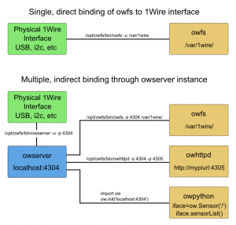](http://www.cupidcontrols.com/wp-content/uploads/2014/01/owfs.png)Methods of attaching to your 1Wire network: directly, or through owserver.

The final commands list for my DS2483 on i2c, which I locate in/etc/rc.local, is:

/opt/owfs/bin/owserver --i2c=/dev/i2c-1:ALL -p 4304

/opt/owfs/bin/owfs -s 4304 /var/1wire/

/opt/owfs/bin/owhttpd -s 4304 -p 4305